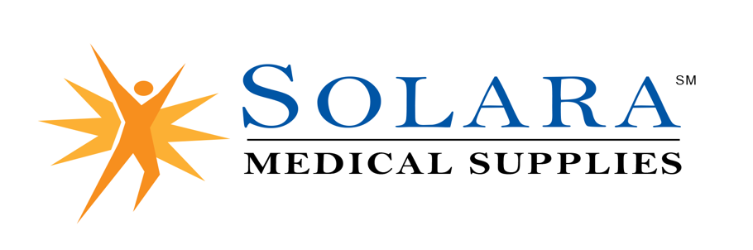
The Client Bill of Rights is designed to recognize, promote, and protect, an individual’s right to be treated with dignity and respect within the health care system. Before service is initiated an individual has the right to be fully informed verbally and in writing of their rights as a client or patient by the providers of health care or services. The individuals receiving services, or their designated representatives may exercise these rights.

As our client you have the right to:
1. Receive information in a way that is understandable to you regarding:
a) organization ownership and control
b) services/products we provide directly or by contract
c) any specific charges for supplies to be paid by you in addition to those charges covered
by insurance third party payment or public benefit programs
d) billing policies, payment procedures and any changes in the information provided at time
of initial purchase
e) instructions and warranty available for purchased products; every product sold by our company carries
manufacturer warranty and Solara Medical Supplies, LLC will honor all warranty coverage under applicable law
f) who to contact, when and how to communicate problems with products or service
g) availability, purpose and appropriate use of Medicare Hotline numbers:
Medicare: Toll Free 1-800-633-4227 during business hours
h) information regarding the organizations liability insurance upon request
2. Receive and access services consistently in a timely manner in accordance with our operational policy; without regard to race, creed, gender, age, handicap, sexual orientation, veteran status or lifestyle.
3. Make informed decisions with your health care provider about your treatment plan and use of supplies ordered.
4. Be notified in advance of product options, when and why delivery will not occur.
5. Be referred to another organization if Solara Medical Supplies, LLC is unable to meet your needs or if you are not satisfied with the products, you are receiving.
6. Participate in the selection of options for alternatives or referral to other organizations, as indicated by your need
for care.
7. Receive disclosure information regarding any beneficial relationship between Solara Medical Supplies, LLC and referred organizations.
8. Direct questions or concerns regarding the performance of your equipment, supplies and/or service to Solara Medical Supplies, LLC at 1-800-999-7516. Please be advised that Solara Medical Supplies, LLC is responsible for resolving your questions or concerns, and it is the company’s goal to respond to questions and concerns in a timely manner. However, you may direct any questions or concerns regarding Solara Medical Supplies, LLC to the Community Health Accreditation Partner (CHAP) an independent non-profit accrediting body at 800-656-9656. Business hours for CHAP are 8:00 A.M. to 5:00 P.M., Monday through Friday. A twenty-four-hour hotline is available by dialing the same phone number after normal business hours and the Utilization Review Accreditation Commission (URAC) at 202-216-9010 Business hours for URAC are 8:30 a.m. to 5:00 p.m., Monday through Friday.
9. Voice grievances or complaints without reprisal.
10. Receive a response from Solara Medical Supplies, LLC regarding investigation and resolution of complaints.
11. Not receive any experimental products without your specific agreement and full understanding of information
explained.
12. Be free from any abusive behavior, neglect or exploitation of any kind by Solara Medical Supplies, LLC staff.
13. Confidentiality of your records and Solara Medical Supplies, LLC policy for accessing and disclosure of records.

Please acknowledge your receipt of the Welcome Packet and Product Warranty & Instructions by signing below and
returning to:

Solara Medical Supplies, LLC • 2084 Otay Lakes Road, Suite 102 • Chula Vista, CA • 91913.

_____________________________________ ______________________________ _____________
Customer Name (print) Customer Signature Date

_____________________________________
Account

